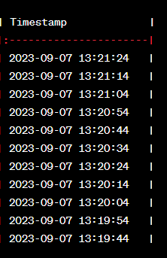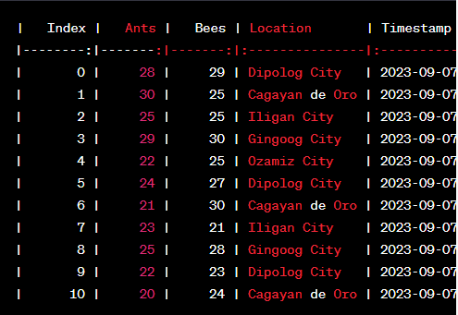

Lets say I have this sample dataset and to query the last value in the database using SQL the syntax will be:

SELECT *

FROM census

ORDER BY Timestamp DESC

LIMIT 1;

Sample output would be:

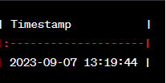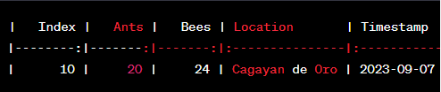

Lets say want to query the last ant value in the database using SQL the syntax will be:

SELECT Ants

FROM census

ORDER BY Timestamp DESC

LIMIT 1;

Sample output would be:

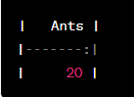

To automatically refresh the web page every 5 seconds to query and display the latest value, you can use JavaScript.

1. What is “ setTimeout(_ , _); “

a function in javascript that accepts 2 arguments. First argument is for another function or you can use anonymous function [ function () {}; ] where you write the code inside that argument rather than writing a function separately and call it, Second argument is time in milliseconds where 1 sec = 1000 milliseconds.

1. Chatgpt introduce location.reload()

a JavaScript method that is used to reload the current web page. It essentially refreshes or reloads the content of the web page in the user's browser.

1. What is “setInterval(_, _); “

We know that setTimeout() first argument which is a function will be executed in set time (milliseconds) later. But for setInterval() is actually the same as setTimeout but the difference is, instead of executing the first argument function only once and set time (in milliseconds) later, setInterval will execute the first argument function over and over again every set time.